Deliverable 02.7.2.1.2E2.
Improve ITFA Performance via Case Evaluations

This task involved retuning of DTF3/DTF5 for use in the RUC20 model from that used in the coarser-resolution RUC40 model, and an analysis of the implications for ITFA. On the premise that the calibration and verification of DTF3 for RUC40 is acceptable, we have used those results to recalibrate and compare DTF3 from RUC20 and RUC40.

Diagnostic turbulence from DTF3 and DTF5 was computed for several cases from the daily RUC40 and RUC20 output. We found that the area coverage of both DTF3 and DTF5 has the tendency to increase with increased resolution. One striking difference is that DTF3 from RUC20 diagnoses turbulence in different areas not present in the RUC40 patterns. Several cases, taken at random, were analyzed and all showed differences, especially above 35,000 ft. These differences are attributed to the higher resolution used in RUC 20 compared to that in RUC40, since it is reasonable to think that the higher the resolution, the more shorter-scale modes should be excited in different areas not present in the RUC40 results. Figs. 1 and 2 show DTF3 diagnostics at 38,000 ft for 1800 UTC 21 August 2002 from the RUC40 and RUC20 models, respectively. The difference of RUC20 minus RUC40 DTF3 fields at this level is displayed in Fig. 3. Although the patterns do not show large areas for this case, they could be larger for more organized weather patterns like those experienced during the winter season. Figs. 4 and 5 show DFT3 for RUC40 and RUC20 for the same case but for 40,000 ft., and the difference fields are given in Fig. 6. In all cases analyzed (similar to the present case) the DTF3 amplitude increases and the differences are more remarkable with increasing elevation.

The recalibration of DTF3 from RUC20 was performed by minimizing the difference between DTF3 from RUC20 and RUC40 after multiplying DTF3 from RUC20 by a factor (= 0.588) to reduce its amplitude. Because only a few cases were used, a rigorous statistical analysis was not done. The recalibration is made difficult due to the fact that the DTF3 patterns are different between the two models. The recalibration factor of DTF3 from RUC10 (10-km grid spacing) was deduced to be ~ 0.2 which demonstrates even further how the amplitude increases with model resolution. Also, the patterns from RUC10 show even greater differences than those found when comparing RUC20 and RUC40.

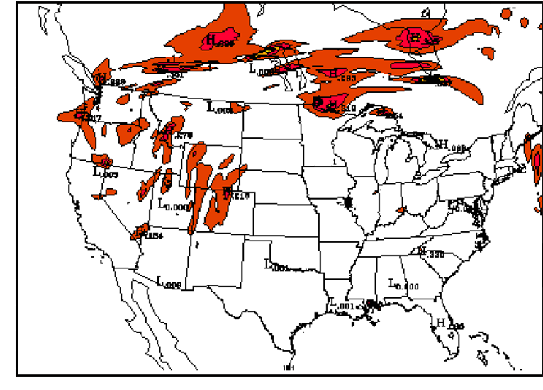

Fig. 1: DTF3 for 21 August 2002 from RUC40 valid at 1800 UTC and for 38,000 ft elevation.

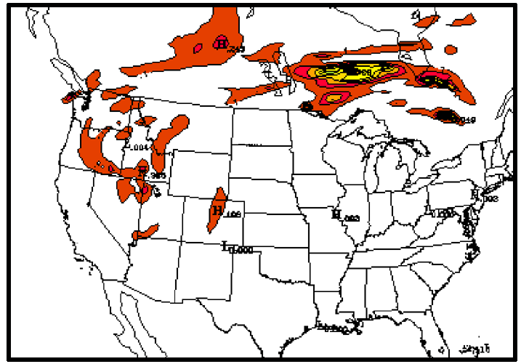

Fig. 2: As for Fig. 1, except for DTF3 from RUC20.

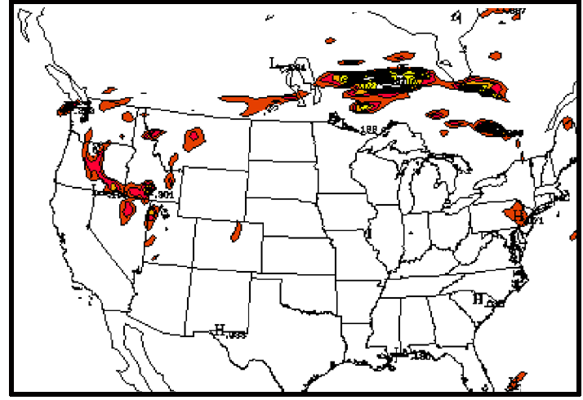

Fig. 3: As in Fig. 1, except for RUC20 minus RUC40 DTF3 fields.

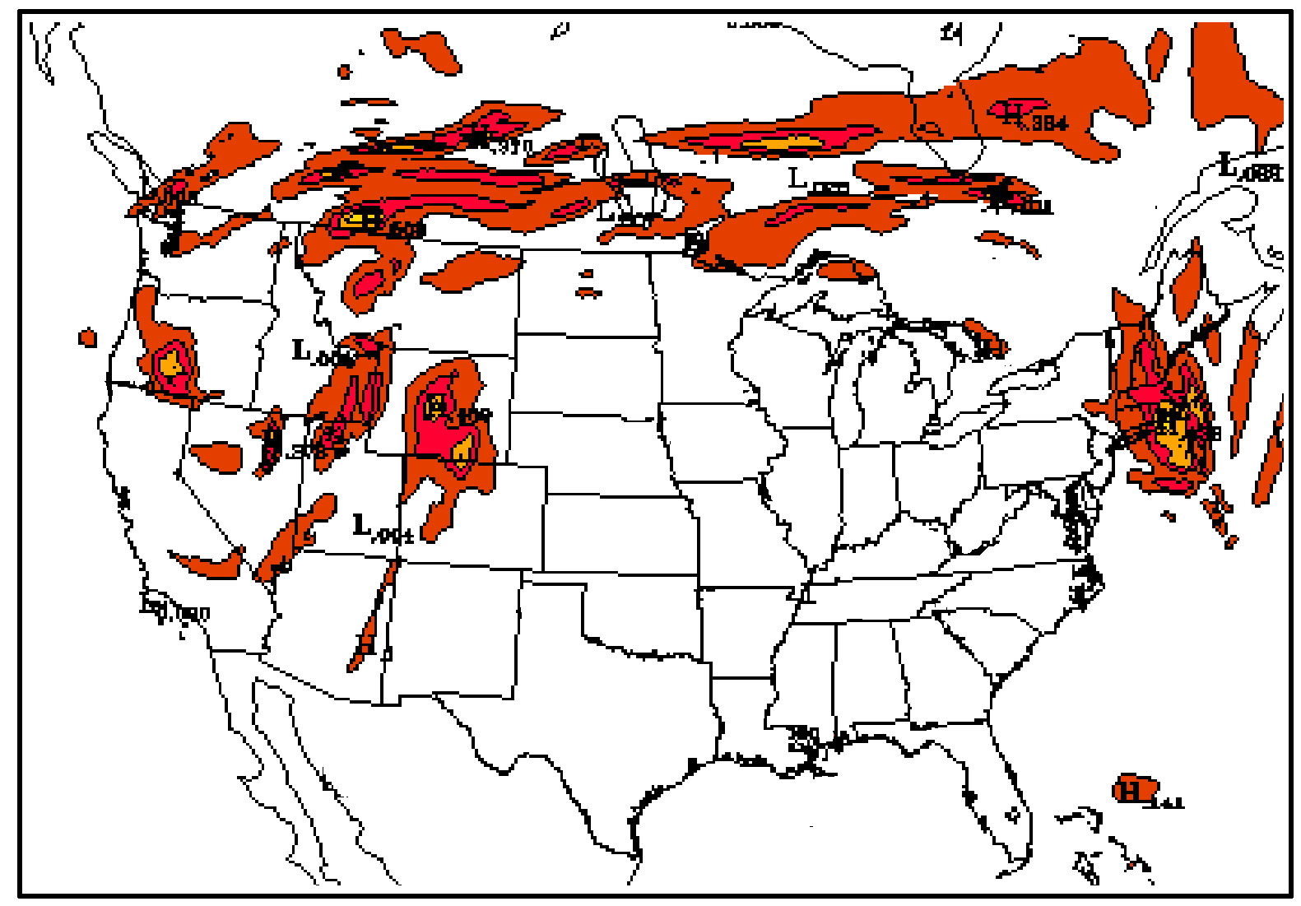

Fig. 4: As in Fig. 1, except for 40,000 ft elevation.

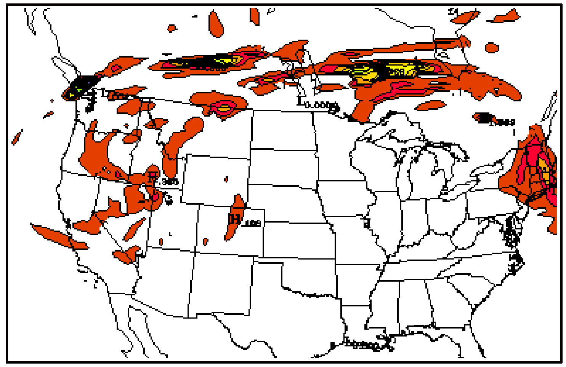

Fig. 5: As in Fig.2, except for 40,000 ft elevation.

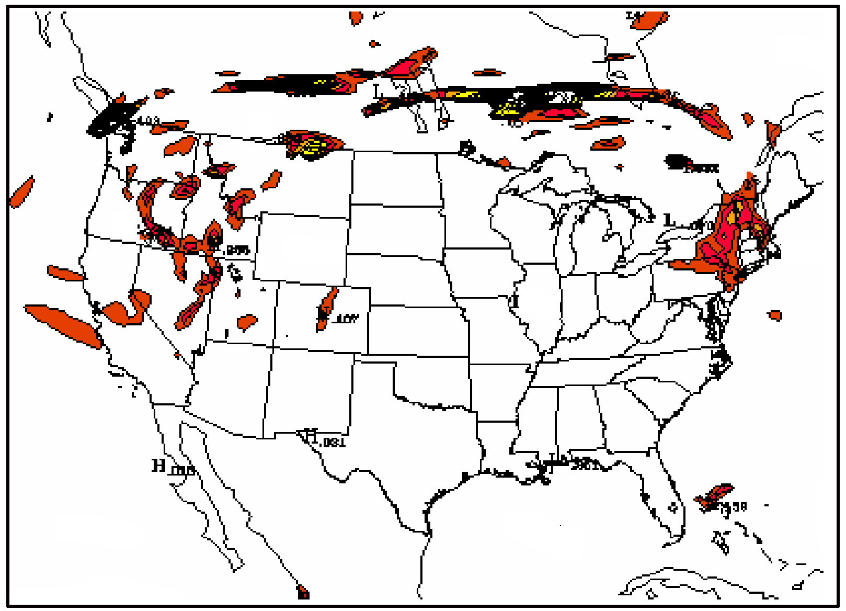

Fig. 6: As in Fig. 3, except for 40,000 ft elevation.

Deliverable 02.7.2.2.8.1E2
Development of upper-level unbalanced flow diagnostic

This task has the objective of developing a new diagnostic for mesoscale gravity waves and associated clear-air turbulence generated by geostrophic adjustment processes associated with unbalanced upper-level jet streaks. The unbalanced flow diagnostic is the residual of the nonlinear balance equation. Since the early part of this year, real-time output from a version of this algorithm has been presented on a web page under the label “Imbalance Residual Turbulence Predictor.” This calculation used isobaric output from the RUC-40km model. An example of this product, based on a 3 h forecast, is presented in Fig. 7. The most coherent part of the imbalance pattern at 300 hPa (about 30,000 ft) over the Rocky Mountains reflects the presence of mountain waves. This product and two others described in previous monthly reports have been archived for further study for a large number of cases from this web page.

Since that time, we learned that the isobaric output of mass and wind fields from the operational RUC20 model is smoothed with a Shuman filter. Unfortunately, smoothing modifies the dynamical relationship between wind and mass fields in a way that makes it difficult to trace its effects on computed imbalances. However, it is reassuring that RUC20 output in its native Hybrid-B coordinate system is not smoothed. We decided to switch the imbalance algorithm from isobaric model output to Hybrid-B output; though this has cost us some time, it has resulted in a much better product to prepare the diagnostic for testing in RTVS and subsequent implementation in the ITFA.

Thus, a change of coordinates was required. Hybrid-B coordinates are neither sigma nor isentropic coordinates. For each horizontal, x-y point there is a vertical stack of points specified by a vertical parameter, no two of which necessarily have the same corresponding set of heights, pressures or potential temperatures. Each Hybrid-B surface, specified by a vertical parameter, is a nearly horizontal surface. The mathematical transformations between generalized vertical coordinates are well known. In computing imbalances from the Hybrid-B model output, one needs to either reformulate the equations for unbalanced flow in Hybrid-B coordinates, or transform quantities derived from finite differences of RUC output in Hybrid-B coordinates, into either isobaric (x-y-p system) or Cartesian (x-y-z system) coordinates. We have chosen to do these calculations in a Cartesian frame of reference. The results are imbalances computed for each point of the Hybrid-B grid point, but referred to a Cartesian frame. The transformations are handled locally through finite difference estimates of the appropriate derivatives. For use as turbulence predictors, imbalance fields are interpolated to a regularly spaced set of height levels.

An example of such results is presented in Fig. 8 for the 23,000 ft level. A total of 9 PIREPS of moderate-or-greater turbulence (crosses in Fig. 8) were registered within ±2000 ft of this level, namely in the Northwest U.S., the Rocky Mountains of Colorado and Wyoming, and a region centered over Minnesota. Imbalances are both positive and negative. An alternative predictor is simply the absolute value of the imbalance field (Fig. 9a). These results are based on unfiltered RUC2 output fields. We also considered whether, after computing with raw model output, some filtering of the imbalance field might be necessary to remove strong noise at the Nyquist wavelength. The figures presented here (compare Fig. 8a to 8b and Fig. 9a to 9b), and others not shown, reveal that some smoothing is beneficial, spreading the signal over a slightly larger area and giving it a more meteorological appearance. Nevertheless, the output from unsmoothed model fields, even though somewhat noisy, has a robust pattern that corresponds well to the meteorological situation.

Our conclusion is to use the smoothed imbalance diagnostics in the Cartesian framework for future development. The corresponding TKE field computed from DTF5 is displayed in Fig. 10 for comparison. Note that the smoothed imbalance field on the local Cartesian coordinate and the TKE fields have somewhat similar structures. They would be redundant if they overlapped perfectly; however, the cross correlation between the two fields reaches a maximum of only 25% at 30,000 ft indicating that the imbalance field contains information beyond what is output by DTF5. The imbalance field can therefore be used as a predictor that is complimentary to the other ITFA algorithms, and we suspect that it may enhance the performance of ITFA. This nature of the imbalance field (complimentary to ITFA algorithms) raises the question of how best to incorporate this field into the ITFA scheme. There is little overlap between the fields. Imbalances are strong where ITFA algorithms are weak and visa versa. We have begun the process of coding a routine that generates imbalance output files in NetCDF format based on the new Cartesian-frame-based algorithm, for the month of September 2002, to be tested statistically relative to PIREPS by NCAR. In the process, we hope to set turbulence prediction thresholds for the imbalance field for this winter’s ’02-’03 RTVS exercise, and for future incorporation into an experimental version of ITFA. The web page mentioned above will be updated to display the new imbalance output based on Hybrid-B RUC output.

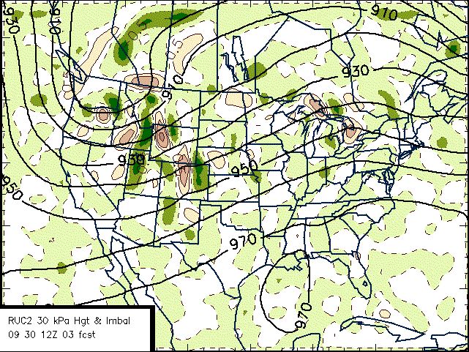
Fig. 7 The residual field from the Nonlinear Balance Equation computed at 300 hPa (~ 30,000 ft) using RUC-40 km 3 h forecast on isobaric levels valid at 1500 UTC 30 September 2002. The field has been smoothed with a low pass filter having a cutoff of 240 km.

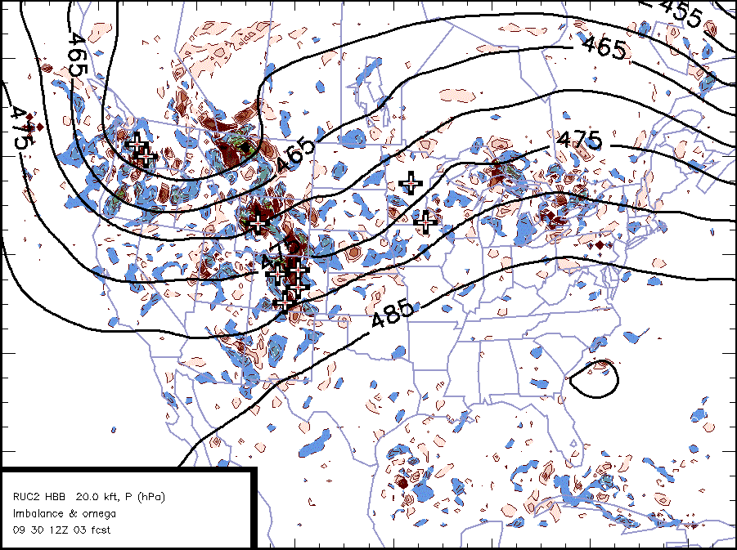
Fig. 8a. The imbalance field at 23 K ft computed from raw (unsmoothed) Hybrid-B, RUC-40 km output for the same time as Fig. 7. Positive (negative) imbalances are in red (blue) shaded contours > 0.5x10⁻⁸ s⁻². The crosses mark the locations of MOG PIREPs within ±2000 ft of this level, and within 90 min of the forecast time.
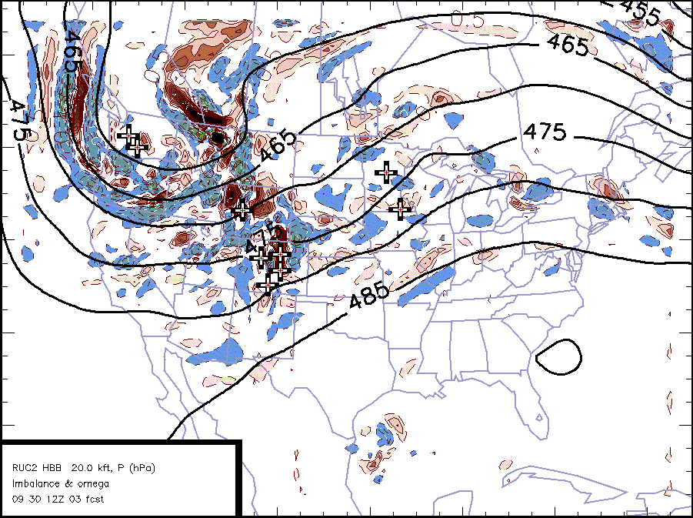
Fig. 8b. The same as in Fig. 8a, except that RUC2 output has been smoothed on all Hybrid-B surfaces using a low-pass filter with a 400 km cut-off wavelength.

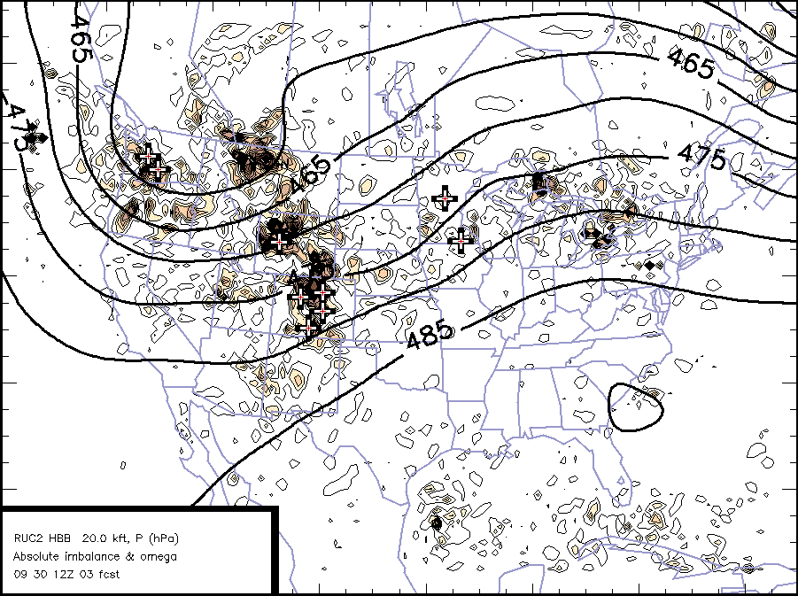
Fig. 9a. Same as in Fig. 8a, but the field displayed is the absolute value of the imbalance field.
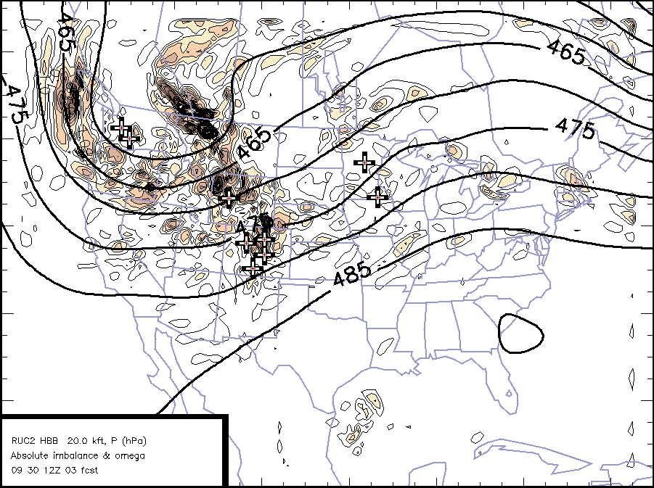
Fig. 9b. Same as in Fig. 8b, but the field displayed is the absolute value of the imbalance field.

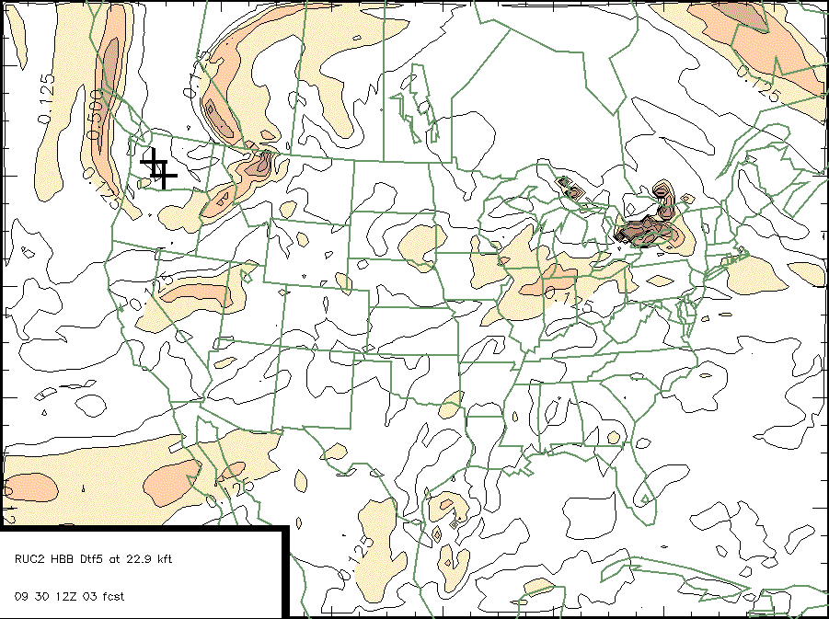
Fig. 10 TKE (m² s⁻²) from the RUC-40 3 h forecast valid for the same time as the above figures, computed with DTF5 and contoured in powers of 2 (shaded above 2⁻³⁾.

Deliverable 02.7.2.4E2
Plans for the winter ’02-’03 aircraft turbulence measurement field program

SCATCAT (Severe Clear Air Turbulence Colliding with Aircraft Traffic) was a field experiment conducted in the winter of 2000 – 2001 to examine turbulence associated with jet streams and upper-level fronts above 20,000 ft over the Pacific Ocean. SCATCAT01 was run in conjunction with the Winter Storms Reconnaissance program with a common base of operations from Honolulu, HI. NOAA’s Gulfstream-IV aircraft measured in situ meteorological quantities and performed dropsonde releases at approximately 50-km intervals through the upper-level jet-frontal systems. SCATCAT aircraft operations attempted to measure atmospheric variables at flight level during the sonde drops as well as through the jet core to document turbulence where the sondes were dropped. Flight level pressure, temperature, and winds were sampled at 1 and 25 Hz (i.e., 1 and 25 samples per second). An experimental, passive ozone sensor was also flown on the Gulfstream-IV by NOAA/Aeronomy Laboratory to explore the usefulness of this sensor as a proxy for tropopause folding and thus of turbulence.

Sondes were dropped in five SCATCAT01 cases. One case contained moderate turbulence; the other four had light turbulence. Compared with cases sampled during NORPEX 98 and WSR99, the 2001 systems were not as interesting. They did not show the multiple laminar layers and prolific wave activity of the cases from the previous years. Nonetheless, as reported in our deliverable report 02.7.2.14.2E1 completed in June 2002, initial meteorological analyses for the top priority case (17 – 18 February 2001) indicate that there were regions of strong vertical wind shear above and below the level of >100-kt max winds in this jet. This jet overlaid a low-level warm front and itself was beneath a vertically propagating gravity wave at approximately 200 hPa. DTF3 indicated turbulence should have occurred above the jet in the vertical gravity wave, at the bottom of a stable layer just below the maximum wind level, and along the warm front. We are currenltly comparing these structures to those simulated by the finest-resolution model as described under task 02.7.2.14.3.1, and expect to complete this task by 15 January 2003.

Based on our experience with conducting data analyses, especially the 18 Feb case, we are in a good position to make several recommendations for carrying out a subsequent turbulence field project in a more optimal manner. First, although the 2001 case analyses are not quite complete, and modeling studies have been delayed, our experience over the past few years of study is that the soundings and flight level data from research aircraft give a good description of atmospheric state for these turbulence studies, and that diagnostic algorithms such as DFT3 predict turbulence in reasonable locations. However, the GPS unit used on the Gulfstream-IV did not allow for data recovery for the first ~35 hPa of sonde fall (dependent upon sonde drop speed). For example, in the 18 Feb case, the aircraft flew at 41,000 ft (12.5 km), but no data other than the flight-level data could be recovered at altitudes above 37,000 ft (11.3 km). This prevented full knowledge of the actual wind shear patterns in the lower stratosphere above the jet core altitude. Thus, our first recommendation is that it would be desirable to fly at a higher level if possible to obtain the maximum information possible about gravity wave activity in this key region of the atmosphere.

Our second recommendation is that a follow-on field program be performed over a data-rich region, such as one centered over Oklahoma. The SCATCAT01 flights were made over ocean regions for several reasons. First, FAA funding could be leveraged with an existing program (NORPEX, WSR). Secondly, these flights allowed us to develop the software infrastructure for analyzing the sounding and flight-level data, and hone our skills for flight operations. However, what has been lacking in the Pacific studies are the corollary data that a land-based experiment can provide, as well as the ability to probe the vertical structure of the vertical waves with stacked aircraft flying simultaneously (e.g., to measure the vertical momentum flux). NOAA’s Aircraft Operations Center (AOC) is housed at McDill AFB in Tampa, which would mean a short ferry time for operations to Oklahoma. This region also contains the National Wind Profiler Demonstration network, dense surface mesonetworks, the CART/ARM array of surface systems, as well as NWS sounding sites, and is overflown by numerous commercial aircraft that transmit ACARS data. Profilers provide wind data up to 14 km above ground. NWS sounding sites can provide special soundings at asynoptic times. ACARS soundings and flight-level data add thousands of winds and temperatures to the mix of data. The Oklahoma Mesonet has been shown by Dr. Koch to be fully capable of resolving mesoscale gravity wave activity, which has been related to both turbulence activity and unbalanced flow diagnostics. NOAA/NSSL also has a number of mobile sounding systems that could be placed for maximum advantage in characterizing the atmosphere. Experimental, dual-wavelength profilers being developed at NOAA/Aeronomy Laboratory appear to have promise for calculating eddy dissipation rate (EDR). Obviously, we would use these to compare with EDR computed from dropsonde, commercial aircraft, RUC and higher-resolution models.

Our final recommendation is to delay the next turbulence field study for one year until the winter of 2003 – 2004. This would allow for completion of both the observational analyses and the numerical simulations from SCATCAT01.

Deliverable 02.7.2.8E2
Develop and evaluate prognostic algorithms for turbulence from the 20-km RUC

We installed the prognostic TKE-epsilon (TKE-ε) algorithm on a non-operational experimental version of the RUC20 model. A preliminary one-dimensional version of the TKE-ε model was tested with soundings for which there were aircraft turbulence reports above 20,000 ft. The Burk-Thompson turbulence scheme used in the operational RUC20 model did not show any skill at diagnosing the turbulence for these cases. In contrast, the TKE- ε showed a clear signal of turbulence that verified well with the reports (Fig. 11). Encouraged by these results, the TKE- ε model was then installed in a fully three-dimensional RUC20 version and tested to investigate its effect on the planetary boundary layer. The results showed that if the factor in the computation of the momentum mixing coefficient was set at 0.009, the boundary layer temperatures were too cold, and if it was set at 1.0 the temperatures were too warm. It was then decided to improve the computation of the momentum mixing coefficient by considering a factor that is a function of the shear, stability, and other basic variables. With this modification the one-dimensional TKE- ε diagnosed turbulence above 20,000 ft for the cases considered. Efforts are now underway to install and test the improved TKE- ε scheme in the operational RUC20 model.

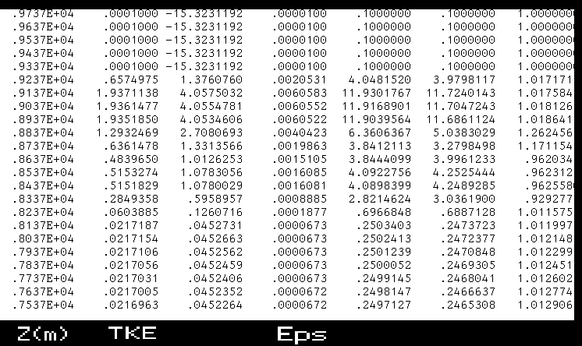

Fig. 11. A test of the one-dimensional TKE- ε scheme for the sounding at Monett, MO (UMN) at 0000 UTC 12 April 1978. Turbulence was reported by a research aircraft at 1700 UTC from 7.0 to 8.2 km (Kennedy and Shapiro 1980, “Further encounters with clear-air turbulence in research aircraft. J. Atmos. Sci., 37, 968-993). The columns labeled Z(m), TKE, and Eps indicate height (m), TKE (m² s⁻²), and dissipation rate of TKE (m s⁻³), respectively. The TKE and Eps columns show diagnosed turbulence between 8.3 – 9.1 km at the time of the sounding. This example shows that the TKE- ε model is capable of diagnosing TKE above 20,000 ft.

Deliverable 02.7.2.14.5E2
Model sensitivity to resolution and parameterization

In April of 2002 the Rapid Update Cycle (RUC) model made the official transition to a horizontal grid resolution of 20 km at the National Center for Environmental Prediction (NCEP), from the previous resolution of 40 km. The purpose of this report is to document the effects of the change in RUC resolution on forecasts of DTF5 (Eddy Dissipation Rate EDR) for non-convective forecasts of potential areas of clear-air turbulence near jetstream level. In addition, there is a prognostic TKE output available from the RUC that is evaluated as a potential forecasting tool for clear- air turbulence at jetstream levels. In this study we took advantage of special RUC forecasts at a horizontal grid resolution of 10 km, one-half the current operational resolution, made in association with a special research project (PACJET), to further investigate the effects of increasing model resolution on forecasts of EDR and TKE from the RUC.

Since the goal was to investigate cases that had potential turbulence not associated with convection or terrain, we looked for cases where there was a prominent jetstream over the continental United States (CONUS). A number of cases were examined from late February through April of 2002, and this report will summarize the main findings, illustrated with selected figures from those cases. The complete collection of cases, including RUC output of TKE and EDR for all three model resolutions (for many of the cases), and where possible reports of turbulence, can be found at the following web site:

http://laps.fsl.noaa.gov/szoke/turbulence/turbulence/ TKE_cases_homepage.html

A summary of the findings from this study is listed below.
- Under the present formulation, TKE at jetstream level (29-43 kft AGL) is basically not present for most of the cases, and where present generally has little areal coverage and very small values. The overall assessment would be that the current calculation of TKE in the RUC is not of use for determining potential clear-air turbulence at jetstream levels.
- For the few instances where TKE was present, the coverage decreased as the resolution of the model increased; that is the RUC20 actually forecast less TKE then the RUC40 (and similarly for the RUC10).
- In contrast, DTF5 EDR (uncalibrated for RUC20 and RUC10) is predicted at jetstream level, generally in areas where the jetstreams are located, and/or where upper troughs exist, as well as sometimes in other areas where the meteorological forcing is not necessarily evident.
- While EDR diagnoses, in general, the areas where turbulence is reported, it covers extensive areas where no reports were received. Although there are limitations to turbulence reports as verifiers for forecasts of turbulence, there is little doubt that EDR overpredicts the area of potential turbulence. A general conclusion would be that EDR has an extremely high Probability of Detection (POD) for turbulence, but a very large False Alarm Ratio (FAR) because of the areal overforecasting. As it was done for RUC40, calibration of DTF5 for RUC20 and RUC10 should be performed to optimize both POD

The points above will be illustrated with selections from the cases that are shown in more detail on the web site. The first example is a comparison between a TKE forecast from the RUC40 (Fig. 12) and a forecast of EDR (Fig. 13) from the same run valid at the same time for 7 March. There are 3 areas of TKE, and they are found in the same location from central Texas southward into Mexico as the much broader area of maximum EDR. The coverage of TKE is far less then the EDR forecast area, and this is typical of all the cases. In fact most cases do not have any TKE, and it should be noted that the values displayed in Fig. 12 are very small. For the cases where there was some TKE forecast, in most of these it was for the RUC40, and the higher resolution runs usually did not have any TKE. This is true for the 7 March case as well, as there was no TKE from the RUC20 and RUC10.

The 2 April case is a good one to illustrate the behavior of DTF5 EDR for the different RUC resolutions. An upper level jetstream was present across much of the CONUS on this day, with a pronounced trough over the central U.S. (Fig. 14), and a subtropical jet across the far southern U.S. Inspection of the EDR forecasts from the three RUC models (Figs. 15 – 17) for 3-hour forecasts valid at 2100 UTC from the 1800 UTC runs indicates that EDR generally encompasses the polar jetstream at the 37,000 foot level, with another maximum near the subtropical jet off the southern California coast. Typical behavior of EDR for the different model resolutions is illustrated by this case; note how the area of maximum values (which is capped at a value of 1.0 for these displays) is larger for the higher resolution RUC displays (implying that the maximum absolute value would also be higher for the higher resolution runs). There is also generally more area covered by a given value of EDR for the RUC20 compared to the RUC40. For the RUC10 compared to the RUC20 this tendency for increasing area of EDR is not as apparent, though in some cases the location of the EDR was a bit different in the RUC10. Generally, the locations of the EDR areas are similar among the three model resolutions. Fig. 18 shows PIREP reports of turbulence for a few hours either side of the 2100 UTC verification time of the model forecasts for flight levels at and above 28,000 feet AGL. The jet level MOG turbulence reports tend to be over the Ohio Valley and mid-Atlantic region, and over most of the southwestern U.S., in particular Colorado, New Mexico, Arizona, and Utah. The ribbon of EDR from western Montana to Colorado and then across to Wisconsin, present at all the model resolutions, does a fair job of encompassing all the turbulence reports, which tended to lie south of the predicted regions. The problem of overprediction is apparent with some of the other areas of EDR, particularly over New England.

Our comparisons among the different resolutions for the RUC models suggest that there is promise in using EDR for prediction of non-convective turbulence at jetstream levels, but that the formulation would benefit from further fine-tuning efforts to reduce the areal coverage and high FAR of EDR. TKE may also be of value, but we cannot conclude very much in that regard from this study. It clearly behaves at the other end of the spectrum compared to EDR, with a severe underforecasting problem that might be improved with further investigation.

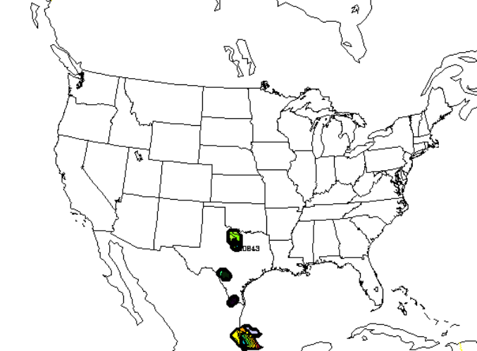

Fig. 12. TKE at 42,000 ft AGL from the RUC 40 km resolution model, 6 h forecast from the 1200 UTC run, valid at 1800 UTC on 7 March 2002.

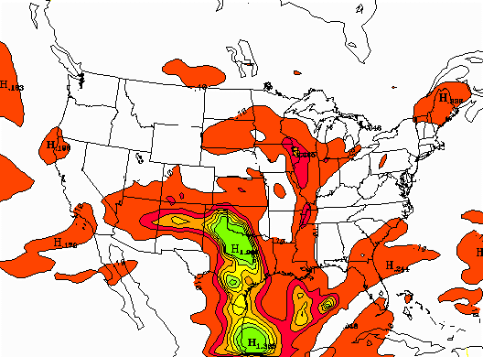
Fig. 13. DTF5 EDR at 41,000 ft AGL from the the RUC 40 km resolution model, 6 h forecast from the 1200 UTC run, valid at 1800 UTC on 7 March 2002.

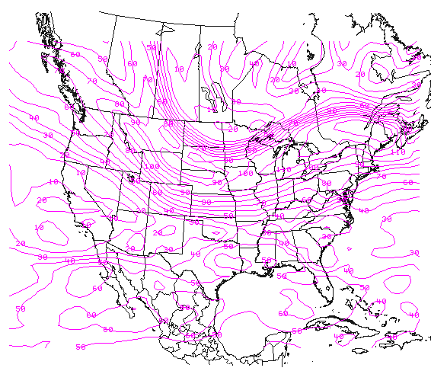

Fig. 14. A 300-mb analysis along with observations, overlaid on a water vapor satellite image for 0000 UTC on 3 April 2002.

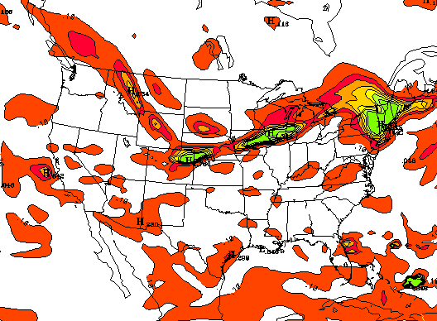
Fig. 15. DTF5 EDR at 37,000 ft AGL from the the RUC 40 km resolution model, 3 h forecast from the 1800 UTC run, valid at 2100 UTC on 2 April 2002.

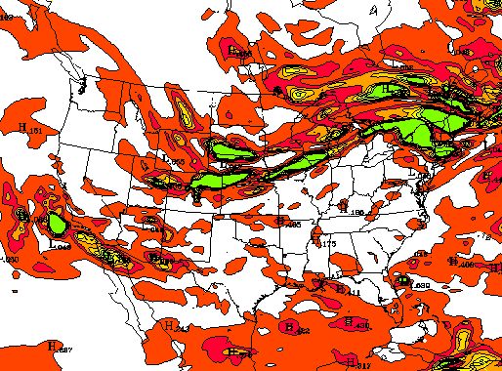

Fig. 16. DTF5 EDR at 37,000 ft AGL from the the RUC 20 km resolution model, 3 h forecast from the 1800 UTC run, valid at 2100 UTC on 2 April 2002.

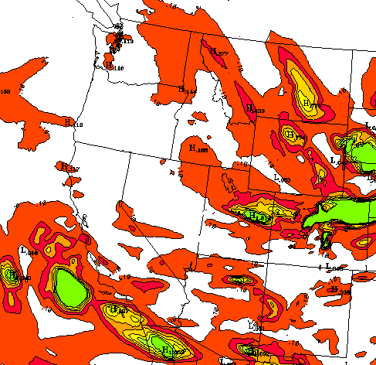

Fig. 17. DTF5 EDR at 37,000 ft AGL from the the RUC 10 km resolution model, 3 h forecast from the 1800 UTC run, valid at 2100 UTC on 2 April 2002.

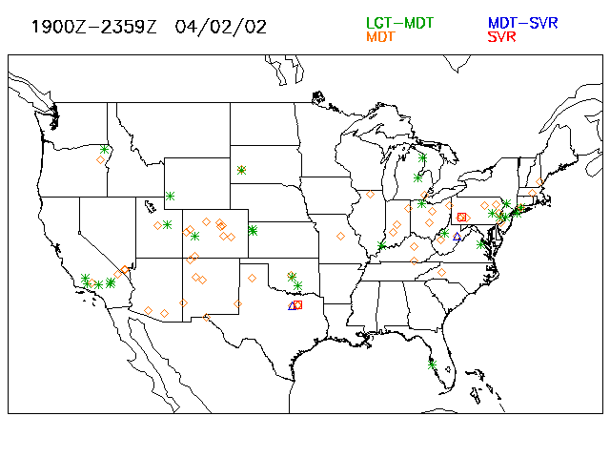

Fig. 18. PIREP reports of turbulence for flight levels atand above 28,000 ft AGL, for the period from 1900 UTC on 2 April 2002 to 0000 UTC on 3 April.

